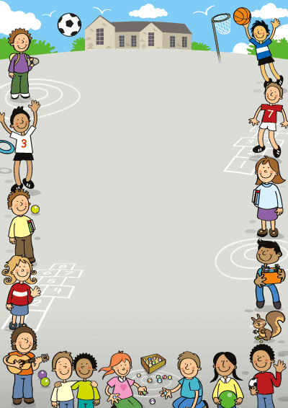

1. **REVIEW AND INTRODUCTORY BOARDGAME**
2. **TENSES BOARDGAME**
3. **EXPRESSING ABILITY IN THE FUTURE**
4. **LONDON WONDERS (x)**
5. **SCHOOL LIFE**
6. **THE PARTY IS ON**
7. **EATING AND TABLE MANNERS**
8. **SPORTS**
9. **WHAT DO YOU DO IN YOUR SPARE TIME?**
10. **PAST CONTINUOUS (x)**
11. **ACCOMMODATION**
12. **TRANSPORT**
13. **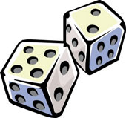HOLIDAY ITINERARY**
14. **SHOPPING IN EDINBURGH**
15. **RELATIONSHIPS**
16. **LET’S HELP OUR PLANET**
17. **PETS**

**Instructions:**

This game is intended to review, practice and consolidate:

-Yes/no questions

-Wh- questions

-Inviting and introducing

You need a dice and counters. Pupils will follow the instructions in each square they land on.

They will either:

1) Answer a yes/no or a Wh- question

2) Invite someone to do something

3) Introduce someone / Describe a place

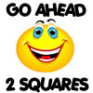

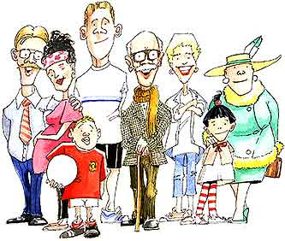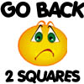[](http://www.clipart.com/en/close-up?o=3866341&memlevel=A&a=a&q=BEACH&k_mode=all&s=22&e=42&show=&c=&cid=&findincat=&g=&cc=&page=2&k_exc=&pubid=)[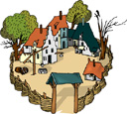](http://www.clipart.com/en/close-up?o=3796670&memlevel=A&a=c&q=VILLAGE&k_mode=all&s=1&e=21&show=&c=&cid=&findincat=&g=&cc=&page=&k_exc=&pubid=)[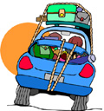](http://www.clipart.com/en/close-up?o=3945028&memlevel=A&a=c&q=TRIP&k_mode=all&s=43&e=63&show=&c=&cid=&findincat=&g=&cc=&page=3&k_exc=&pubid=)[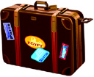](http://www.clipart.com/en/close-up?o=3928440&memlevel=A&a=c&q=SUITCASE&k_mode=all&s=1&e=21&show=&c=&cid=&findincat=&g=&cc=&page=&k_exc=&pubid=)

**20**

**Where did you spend your summer holidays? What did you do? What did you like or dislike?**

**19**

**18**

**17**

**16**

**15**

**14**

**7**

**8**

**9**

**10**

**11**

**12**

**13**

**1**

**2**

**3**

**4**

**5**

**6**

Play again

**Introduce yourself and ask a partner about his/her name/ hobbies/ family/ school...**

**Do you have friends from other countries? If no, would you like to have a foreign friend? Why / why not?**

**Introduce your brother(s)/ sister(s) to a group of friends.**

**Invite your new neighbours to have dinner at your house.**

**Introduce your neighbours and ask a friend about his/ hers.**

Play again

**Introduce your best friend’s family.**

**Did you spend holidays at a friend’s or relative’s house? Did you like it? If not would you like to do it? Why? Why not?**

**Where would you like to spend your next holidays and why?**

**Introduce your grandparents: names/ ages/ jobs and hobbies.**

**Introduce your parents: names, ages, jobs and hobbies and ask a partner about his/hers.**

**Talk about your hometown, its characteristics and the best time of year to visit it.**

**Ask a friend about where he spent his summer holidays, what he did then and what he liked or disliked.**

**Invite your English friend to spend the next holidays with you in Tunisia. Enact the dialogue.**

Instructions:

There will be 3 dices: a numbers dice, a personal pronouns dice and a tense dice

And 3 cards: negative/ interrogative and affirmative form.

Divide your pupils into groups. Group leaders cast the number dice. The group that gets the highest number on the dice starts first.

Now that we know the order of the groups, we will play the game this way:

Each group casts the 3 dices at the same time and picks a card.

Example:

The number dice lands on square (6): cook dinner/ the personal pronouns dice lands on (they) the tense dice lands on (future) and the card says (negative).

The group has to make a (negative) sentence using (cook dinner) in the future tense with (they)

The winner is the group that finishes first.

If a group fails to make an accurate sentence it can get feedback from the other groups or from the teacher and miss a turn

**Take an extra turn**

**Not go to school**

**Cook dinner**

**12**

**13**

**14**

**15**

**Be free to go out**

**16**

**Go back 2 spaces**

**17**

**11**

**10**

**Make a cake**

**18**

**Set the table**

**19**

**Have a shower**

**20**

**21**

**22**

**Go down to the shop**

**Send an e-mail**

**Go to work**

Walk the dog

**Sell fresh bread and cakes**

**Call a friend**

**25**

**24**

**23**

**Want to visit relatives**

**Write a letter to my English penfriend**

**26**

**27**

**Have a cup of tea**

**Feed the cat**

**29**

**Go to sleep**

**28**

**Miss one turn**

**Make the beds**

**Wash the dishes**

**9**

**Fix the fridge**

**3**

**Go ahead 2 spaces**

**2**

**4**

**5**

**6**

**7**

**8**

**Go to the market**

**Not write a letter**

**1**

**Clean the floor**

**Help mum**

**Buy bread**

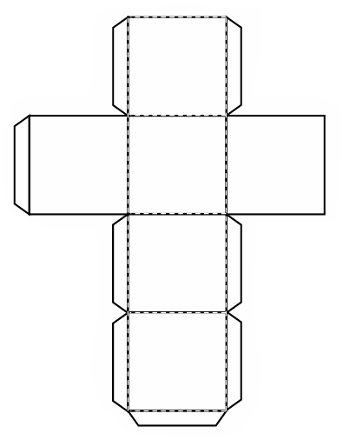

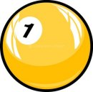

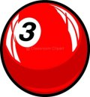

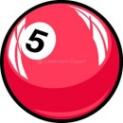

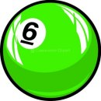



MCj04257600000[1]MCj04280750000[1]



Play tennis well/ in a few months

Drive a car/ at the age of 18

Walk/ when the plaster is removed

Walk / at the age of 18 months

Do the washing-up/ after work

MCj03101580000[1]MCj00896500000[1]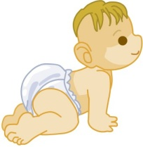

MCj03187520000[1]

**4**

**3**

**2**

**1**

Sick / Not go to school tomorrow

Sleep/ when baby stops crying

Eat/ when his tooth gets better

Cross the street/ when the light turns green

Not do homework/ Fell asleep

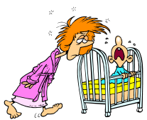

boy in bed; woman 
feeling his forehead. 
fotosearch - search 
clipart, illustration, 
drawings and vector 
eps graphics images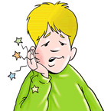[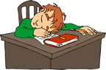](http://www.dinosoria.com/clipart_ecole/pages/G0451334_gif.htm)

**10**

**5**

**9**

**8**

**7**

**6**

Get married/ when her parents agree

Swim without a life buoy/ when he gets older

Leave the hospital/ when she recovers

Go back to London / after the holidays

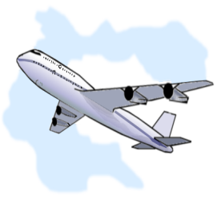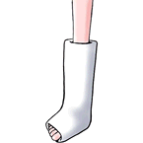

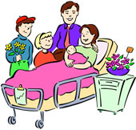

**14**

**13**

**12**

**11**

Leave for the station/ when the suitcase is packed

Not pay groceries/

Lost his wallet

Not travel/ Passport not ready

Not take the children to school/ have a flat tyre

Not write/ Hurt a finger/



[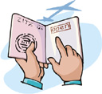](http://www.clipart.com/en/close-up?o=3835596&memlevel=A&a=a&q=PASSPORT&k_mode=all&s=1&e=21&show=&c=&cid=&findincat=&g=&cc=&page=&k_exc=&pubid=)

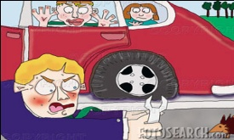

MCj03209540000[1]

**19**

**16**

**18**

**17**

**15**



Play outside / when the rain stops

Not make a phone call/

Have a low battery

Serve dinner/ when it’s ready

Watch a movie/ after the news

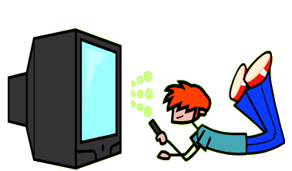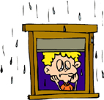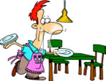

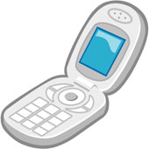

**20**

**21**

**22**

**23**

**Instructions:**

This game is meant to practice “expressing ability in the future”.

You need the numbers dice/ personal pronouns dice, the form cards (affirmative/ negative/ interrogative) and counters.

Divide your pupils into groups. The group that gets the highest number on the dice starts first. At each turn a group member casts the dices and picks a form card.

For ex:

A group member casts the numbers dice and gets (3)

He casts the personal pronouns dice and gets (she)

He picks a card and gets (affirmative form)

Then he has to do this:

At the age of 18 months, she won’t be able to walk.





**Instructions:**

Divide your pupils into groups. Group leaders cast the dice. The group that gets the highest number on the dice starts first.

Each group casts the dice.

The pictures in this game represent different parts of the school building. 1) If they land on a picture, the group has to identify the part of the school represented by the picture and use the word in a sentence to locate that place in their own school.

2) If it lands on a question, pupils will have to give a one minute talk about it.

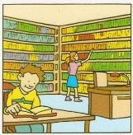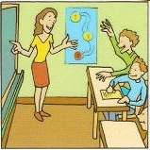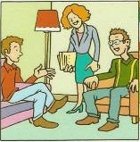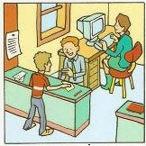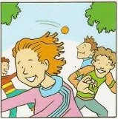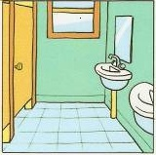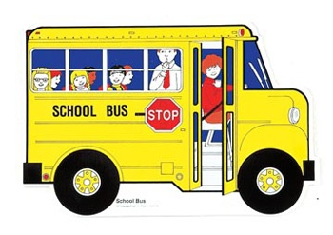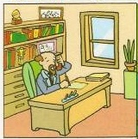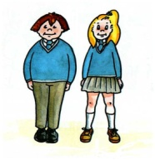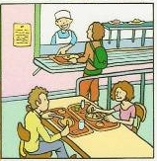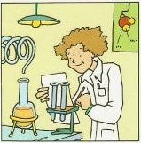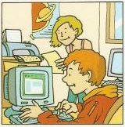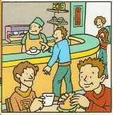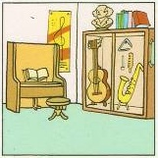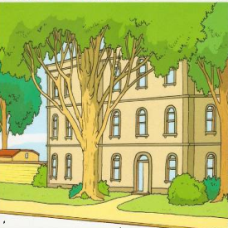

**22**

**21**

**20**

**17**

**18**

**19**

**15**

**14**

**13**

**12**

**16**

Are there breaks between classes? When are those breaks and how long do they last?

Describe your ideal school.

What’s the name of the school principal?

Do you like school? Why? Why not?

Where do pupils have lunch in private/ state schools?

**8**

**9**

**4**

**5**

**6**

**7**

**11**

**10**

Do you wear a school uniform? Describe it.

What sports do you practice at school?

When does your school day/year start/end?

How do you go to school?

**3**

**2**

How many school subjects do you study at school? What are they?

**1**

**Instructions:**

Divide your pupils into groups. Group leaders cast the dice. The group that gets the highest number on the dice starts first.

Each group casts the dice.

1) If it lands on a picture, the group has to make a sentence about the picture using the present progressive tense.

**Example:**

Picture 1/ Square2: They are dancing.

2) If it lands on a square containing an instruction: Invite someone or name 3 kinds of parties (…), the pupils will have to follow the instruction.

**Follow-up:**

pupils are divided into group and are asked to pick up a card containing one of these questios.

-What do hosts do after a party

-What do hosts do before a party

-What do guests do during a party

-What items should be on a party shopping list

The Winner is the group which provides the most complete list.

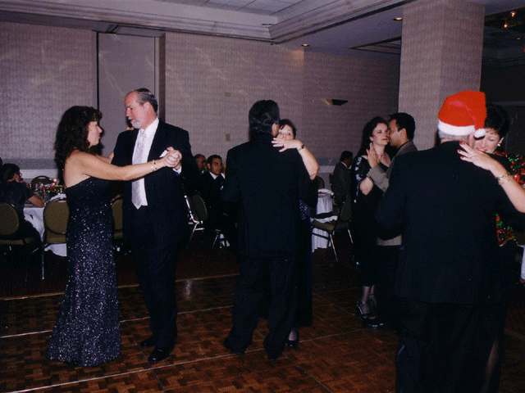

Name 3 items on a shopping list for a birthday party

Name 3 kinds of parties

You’re hosting a party. Name 3 things you need to do.

You’re hosting a party.

How can you invite people to it?

You invited someone to dance with you. He/she accepted. Enact the conversation

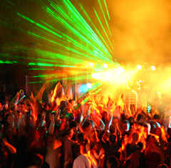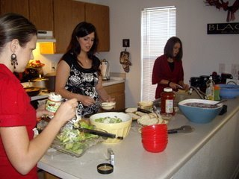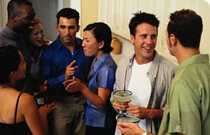

**20**

What do you call a person hosting a party?

**22**

**21**

You’re meeting a friend to go to a party together. Arrange to meet him by phone.

Enact the conversation

**17**

**16**

**12**

**13**

**14**

**15**

**19**

**18**

Give 3 adjectives to describe people’s appearance at a party

Complete the conversation.

Can you come to my birthday party next Sunday?

----------------------------

Name 3 items on a shopping list for a birthday party

**10**

**9**

Someone invites you to have a drink. You accept. Enact the conversation

**8**

Name 3 decorative items for a party

Name 3 activities guests can do at a party

Name 3 things people mustn’t do at a party

Name 3 things guests do before going to party

Name 3 places in which you can throw a party.

**11**

Name 3 necessary items on a shopping list for a party dinner

**7**

**6**

**5**

**4**

**3**

**2**

**1**

**Instructions:**

Divide your pupils into groups. Group leaders cast the dice. The group that gets the highest number on the dice starts first.

Each group casts the dice. If it lands on a “picture square”, the group has to label the picture and use it in a sentence. If it lands on a “multiple choice square”, group members have to choose the right answer. If they don’t get it right, the group has to miss a turn.

The right answer will not be given so that other groups can find it if they happen to land on the same square. If no group manages to get the answer, it will be given at the end of the game either by the teacher.

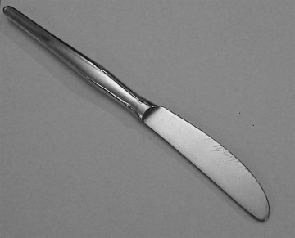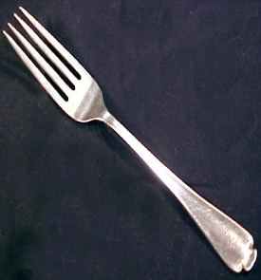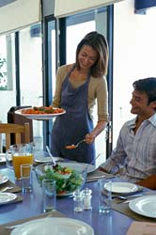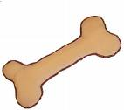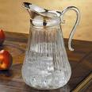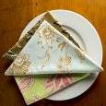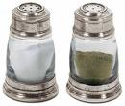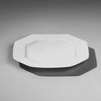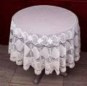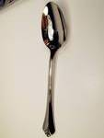

17

18

16

12

13

14

15

8

9

10

11

5

6

7

3

2

1

4

***Roast the meat:***

***- Fry the meat***

***- Bake the meat***

***- Heat the meat***

***Don’t sniff your food:***

***- Don’t taste the food***

***- Don’t swallow the food***

***- Don’t smell the food***

***Clear the table means:***

***- Place plates on the table***

***- Take away dirty plates***

***- Remove chairs off the table***

***Put the salad dressing means:***

***- Put a napkin to cover the salad***

***- Put oil and vinegar on it***

***- Put it in a special plate***

***Stop slurping means:***

***- Make noise with your lips while eating***

***-Roll your tongue while eating***

***- Burp after eating***

***Lay the table means:***

***-Place plates, forks and spoons on the table***

***-Clean the table***

***-Put the table cloth on the table***

***Don’t stretch out to get the salt means:***

***- Don’t extend your arm to take it***

***- Don’t ask someone to hand it over***

***- Don’t leave your place to take it***

***Don’t dip bread means: Don’t***

***- drown it in the sauce***

***- Use it to eat the sauce***

***- Use it to wipe your mouth***

***Don’t munch food means: Don’t***

***- Chew with much movement***

***- Eat with pleasure***

***- Eat with your* *mouth open.***

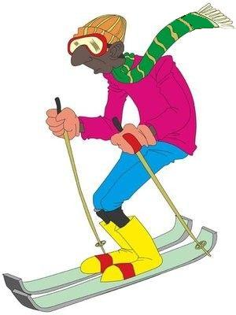

**1**

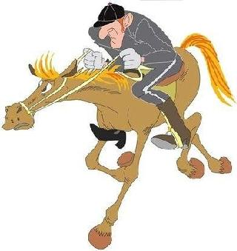

Athletes wear special gloves and punch until 1 of them is knocked out

**3**

**2**

**7**

Athletes slam and dunk the ball into a hanging basket-like ring.

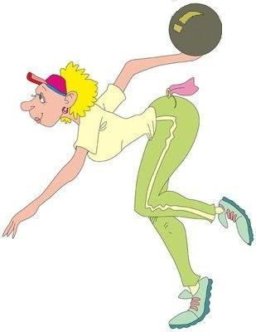

A team sport where Athletes dribble and kick the ball.

**6**

**5**

**4**

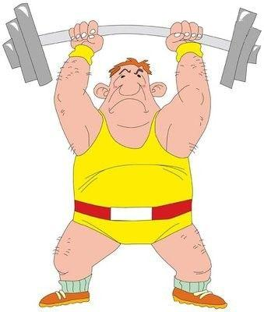

**10**

Athletes use a board to move very fast and do acrobatic stunts over water.

A game played with an oval ball that may be kicked or thrown.



**11**

**8**

**9**

**13**

**14**

**15**

An indoor sport where 1 or 2 dancers dance on the ice rink in front of judges

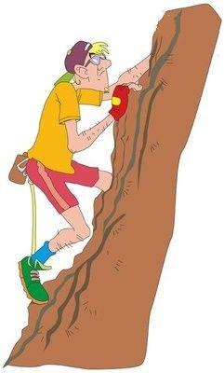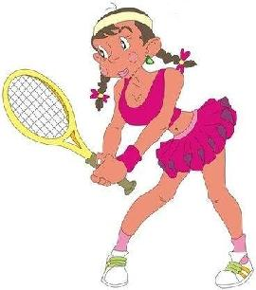

**12**

A pitcher throws the ball and a batter hits the ball with a bat

2 teams play on a court divided by a high net. They hit a ball backwards and forwards over the net with their hands.

Athletes must ride their bicycles to the end line.

**19**

**17**



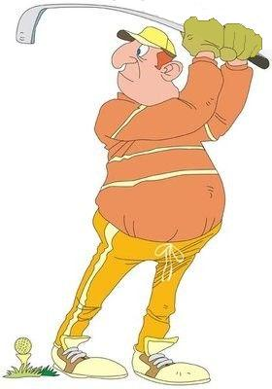

**18**

**Instructions:**

Divide your pupils into groups. Group leaders cast the dice. The group that gets the highest number on the dice starts first.

Each group casts the dice. If it lands on a picture, the group has to label the picture and use the word in a sentence. If it lands on a definition, the group has to guess the name of the sport.

Instructions:

This game is meant to practice:

- The use of the structure (spend+ time phrase).

- The past continuous tense.

- Vocabulary related to leisure activities.

To play the game you need 2 dices: a numbers dice and the questions dice given below.

Divide your students into groups. Group leaders cast the numbers dice. The group that gets the highest number on the dice starts first.

Groups cast both dices.

The group has to answer the question (on the questions dice) using the picture of the leisure activity (represented in the square the numbers dice landed on.)

**Example:**

Square1:

How did they spend their time yesterday?

They spent their time painting.



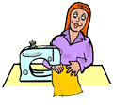MCj03967260000[1]j0424652[1]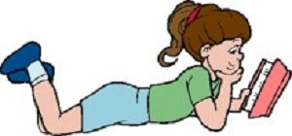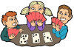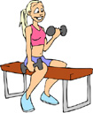MCj03341680000[1][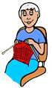](http://www.clipsahoy.com/webgraphics2/aw4161.htm)MCj04080300000[1]MCj02959980000[1]MCj04300890000[1]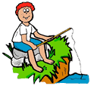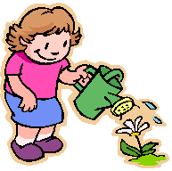MCj03967140000[1]j0396732[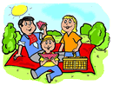](http://www.clipsahoy.com/webgraphics2/aw4516.htm)MCj03340880000[1]MCj04284170000[1]MCj03982590000[1]MCj04159780000[1]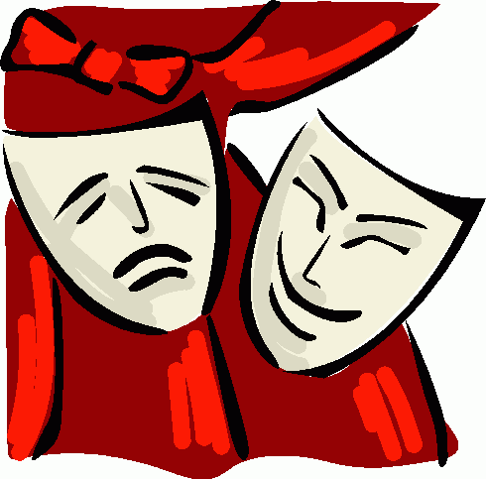MCj02329100000[1][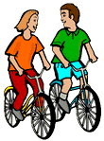](http://www.clipsahoy.com/webgraphics2/as3703.htm)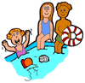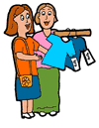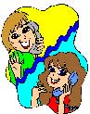[](http://www.fotosearch.com/bthumb/ICL/ICL159/SWO_146C.jpg)MCj00890920000[1]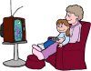

MCj04239900000[1]MCj04239900000[1]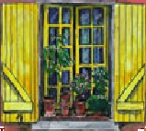

15

14

13

12

11

10

9

8

7

6

1

2

3

4

5

# 5-Star Hotel

**weekend**

**double room**

**Must have Spa facilities**

# 4-Star Hotel/1 Night

**Double room Queen-sized bed**

**Breakfast only**

**Require room service**

**Wake-up call at 7o’clock**

**A building ran by a private operator. Beds, meals & other services & facilities are provided. People can stay there & eat fairly cheaply.**

**1) Hotel**

**2) Motel**

**3) Hostel**

# Bed & breakfast

**2 days**

**1 Single room**

**1double room both with private facilities**

**A boat which is designed and equipped for living in; It can accommodate as many people as its size allows.**

**1) Lighthouse**

**2) Houseboat**

**3) Guesthouse**

# 4-Star Hotel

**1 Week**

**2 Single rooms both with internet connection**

**No food included**

**A tower accompanied by a small house containing no more than 3 rooms. It accommodates 1 or 2 people maximum.**

**1) 3-star hotel**

**2) Motel**

**3) Lighthouse**

# Guesthouse

**2 Nights**

**Single room**

**Breakfast**

**Quiet location**

**No children**

**Accommodation offering bed and breakfast usually in a private house; It accommodates no more than 6 guests & may serve an evening meal.**

**1) Motel**

**2) Bed & breakfast**

**3) Inn**

**3-star hotel**

**4 Nights**

**Breakfast and lunch required**

**Fax machine, internet and photo copier required.**

**It can have 6 to 20 letting bedrooms. Most rooms have private facilities. Breakfast, lunch and dinner are served. It’s usually run by the owner(s).**

**1) Hotel**

**2) Motel**

**3) Inn**

# 2-Star Hotel

**4 Nights**

**Double room with queen-sized beds**

**Breakfast only**

**Bed and breakfast accommodation within a traditional bar or pub. The bar and restaurant are open to non-residents.**

**1) 3- star Hotel**

**2) Bed and breakfast**

**3) Inn**

**A top class type of accommodation that offers high quality services. It also has a range of leisure, spa, shopping & sporting facilities.**

**1) 3- star Hotel**

**2) Motel**

**3) 5- star Hotel**

**A house that has at least 4 bedrooms, some of which come with private facilities. Breakfast is available and evening meals may be provided.**

**1) Hotel**

**2) Houseboat**

**3) Guesthouse**



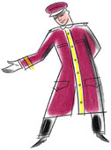

Instructions:

Divide your pupils into groups. Group leaders cast the dice. The group that gets the highest number on the dice starts first.

Each group casts the dice. If it lands on a multiple choice, group members have to choose the right answer. If they don’t get it right, the group has to miss a turn and the right answer will not be given so that other groups can provide it if they happen to land on the same square. If no group manages to get the answer, it will be given at the end of the game either by the teacher or pupils.

If the group lands on a (make a conversation square) they have to enact a conversation using the information provided.

Instructions:

Divide your pupils into groups. Group leaders cast the dice. The group that gets the highest number on the dice starts first.

Each group casts the dice.

1) If it lands on a picture, the group has to label the picture and use it in a sentence.

2) If it lands on a conversation question square, the pupils will have to answer or discuss the question.

MCj03209540000[1]bd07281_MCj03209740000[1]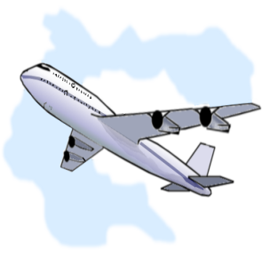MCTN00561_0000[1]

**Instructions:**

Divide your pupils into groups. Group leaders cast the dice. The group that gets the highest number on the dice starts first.

The game looks like a holiday itinerary. It goes this way:

A friend’s invitation to visit London 🢂 going to the bank to get some money for the trip 🢂 buying tickets at the travel agency 🢂 Booking a room 🢂 Buying train tickets 🢂 shopping etc…

The traveller has to enact conversations at each step of his journey.

Each group casts the dice and enacts the conversation as instructed in the square it lands on.

If the pupils get stuck, there are helping cards for each context to lend them a hand. You can organize these helping cards by context and put them in envelopes. Each envelope contains cards related to a specific context.

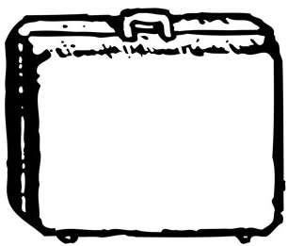Example:

At the bank

I’d like to cash a cheque

Each Group will be allowed to take a maximum of 2 helping cards per conversation.

Contexts:

**Post office / bank/ market/ shoe shop/ clothes shop/ travel agency/ train station/ hotel/ restaurant/ Asking parents for permission to go to London/ thanking friend for invitation/ souvenirs shop/ family meeting.**

The cards in blue can be used in more than 1 context.



How much is it?

I would like to book a room.

I would like to send a package.





What’s your account number?

I’d like to deposit some money.

Can I have the receiver’s address?



What size are you?

I’d like to cash a cheque.

This isn’t the right size.





That will be 50£

Ok, can I have your name please?

When are you checking out?



Can I go to London?

Yes, we have some nice shoes over there.

One return ticket to Edinburgh please.



Would you like me to wrap it up for you?

Can I see this vase over there on the stall please?

Where will you stay?



A kilo of kiwis please.

Come visit me in Tunisia this summer.

I really liked London. Thanks for everything.





Do you want to try it/ them on?

That will be £2, 99

Can I pay by credit card?



I’d like salad and soup, please.

When is the next train to Edinburgh?

What can I do for you?





Can I see your passport, please?

Would you like to order now?

Small or big notes?



Why do you want to go to London?

Single or return?

Single or double?





I’d like to draw 500 dinars, please.

Is that all?

I’d like to book a plane ticket to London.



Everything was nice except the food.

What did you do?

How was your trip?

.

MCj04046110000[1]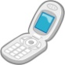MCj03209540000[1]MCj04132980000[1]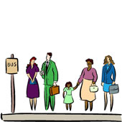[](http://www.clipart.com/en/close-up?o=3835596&memlevel=A&a=a&q=PASSPORT&k_mode=all&s=1&e=21&show=&c=&cid=&findincat=&g=&cc=&page=&k_exc=&pubid=)MCBS00508_0000[1]MCj02508130000[1]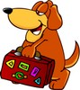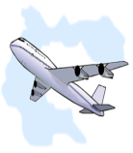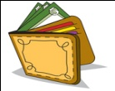MCj04122720000[1]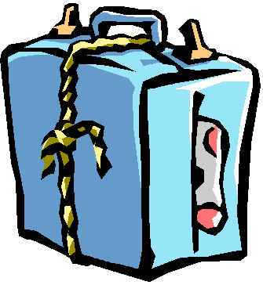

21

22

23

24

25

20

19

18

17

16

11

12

13

14

15

10

9

8

7

6

1

5

4

3

2

**Go to the Bank to draw money for your trip to London**

**On your 2nd day, you decide to go sightseeing. Go to the Train station& buy a ticket to Edinburgh.**

**You’re at the airport. Call your family to tell them that your plane landed.**

**Call your English friend to thank him. Invite him to come and visit your country.**

**Go to the Post office**

**Send a “thank- you” gift to your friend in a package.**

**Wake up!!!**

**It’s time to stay with your family to tell them about your trip.**

You are exhausted after a long plane trip. Have a little nap.

Miss a turn

You’re out of money go back to the B&B.

Miss a turn

**You have to go to a Souvenirs shop to buy souvenirs for your family.**

**Go to the Market**

**And buy yourself some delicious exotic fruits**

You lost your purse in the market. Go back to the B&B to get some money.

Miss a turn.

It’s Time to go home.

You’re on the plane back to your country. Go forward 2 squares

**You’re in Edinburgh. Go to a Bed & breakfast**

**Book a room for the night.**

You’re on the train to Edinburgh.

Miss a turn

You forgot your wallet in the shoe shop! Go back and get it.

Miss a turn

**You see a trendy pair of shoes in a Shoe shop window.**

**Buy it.**

You’re on the plane to London.

Go forward 2 spaces and play again.

**You have to find a place to stay in. Your friend takes you to a**

**3-star hotel to**

**Book a room**

You’re going to town centre to do some shopping. Wait for the bus

Miss a turn

**You’re in a clothes shop. Buy yourself some nice clothes**

**Time for lunch go to a nearby Restaurant and order a meal**

You’re waiting for a taxi to take you to the airport!

Miss a turn

**Travel agency:**

**Buy a ticket to London**

Go back to the bank you forgot your ID!

Miss a turn

**Your English penfriend invited you to visit him in London. Ask for your parents’ permission & convince them to accept. 1**

**Instructions:**

You need a dice and counters.

This game deals with the theme of “relationships”.

Divide your pupils into groups. Group leaders cast the dice. The group that gets the highest number on the dice starts first.

Throughout the game pupils will find problematic situations to which they will try to suggest solutions and give advice.

When a group is playing, the other groups will judge the advice it gave to the problem.

If they raise the red light it means that the advice is not pertinent and will not be accepted and then the group will miss a turn.

If they raise the orange light it means that the group can have another chance to reformulate it.

If they raise the green light it means that the advice is appropriate to the situation.

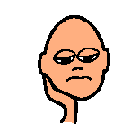

**My parents don’t let me stay out late.**

**My parents spoil my little sister and forget about me.**

**My parents are never there for me when I need them.**

**My brother’s dog peed on my books so I threw it outside and now my brother is very upset.**

**My sister sticks her nose a lot in my life.**

**I had a bad mark yesterday and I don’t know how to tell my parents.**

**I don’t get on well with my parents.**

**Nobody at school wants to be my friend.**

**My daughter is very aggressive with her little sister.**

**Everybody says that my sister is prettier than me and I feel jealous.**

**I had a fight with my best friend and now I feel lonely.**

**I want to meet new friends**

**I want to leave the house because my parents are too severe.**

**My parents refuse to let me go out with my friends.**

**I want a pet but my**

**Parents refuse to buy me one.**

**My neighbours are very annoying.**

**My son isn’t doing   
well at school and   
sometimes he   
misses lessons.**

**I think that my parents hate me because I am bad at school.**

**I lied to my parents and now I feel terrible.**

**I am bored and I don’t have friends**

**My friend borrowed my favourite dress and won’t give it back to me.**

**My mother is over-protective and it gets on my nerves.**

**My mother is always busy and she doesn’t have time to listen to my problems**

**My son is allergic to animals but he wants a pet.**

**My mother doesn’t like my best friend.**

**I hate my little brother.**

Let’s help our planet

**Instructions:**

You need a dice and counters.

Divide your pupils into groups. Group leaders cast the dice. The group that gets the highest number on the dice starts first.

This game is based on conversation questions related to the topic of “environment”

Pupils will cast the dice and answer the questions on the squares they land on.

Let’s help our planet

Give a solution to solve the problem of water scarcity.

What environmental problems can means of transport cause?

Name an invention that helps save energy.

Name an eco-friendly means of transport

Name 1 thing you can do to preserve the environment.

Name 1 thing that you do, that causes ecological problems.

Name 3 environmental problems our planet suffers from.

**Start**

Name something you can do at home to save energy.

What can you do at home to help the planet?

Do you think using public transport instead of cars solves the problem of air pollution?

Name something that people use or do which is bad for the environment.

How can we make our environment safer, nicer and healthier?

Do schools have a role in teaching children how to preserve the planet?

Are people aware of environmental problems?

What role do parents have in helping the planet within their families?

Name 2 types of pollution.

Name an invention that is a threat to the environment.

Who must be responsible for protecting the planet?

What do you think governments should do to preserve the environment?

What should be the punishment for throwing garbage in the street?

When do we celebrate «earth day »?

What does this symbol represent?

[](http://images.google.com/imgres?imgurl=http://www.bserecycling.com/images/recycle.jpg&imgrefurl=http://www.bserecycling.com/&h=624&w=624&sz=116&hl=fr&start=1&tbnid=vUyimTyEnl28DM:&tbnh=136&tbnw=136&prev=/images%3Fq%3Drecycle%26gbv%3D2%26hl%3Dfr)

Name 1 thing you want to stop doing to help our planet.

What’s the biggest threat to the environment?

What can you do to encourage pupils to clean their schools?

13

12

11

What should be the reward of people who care for the environment?

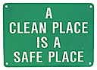

14

10

9

8

7

6

j0104572

Name 3 things that can be recycled.

Is there still hope for our planet?

15

5

30

28

29

**Finish!**





16

4

27

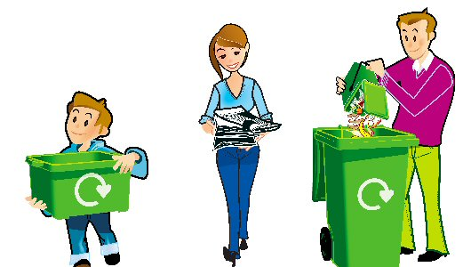

17

What will happen to the earth in the future?

3

18

26

What’s the role of T.V and radio advertising in preserving the environment?

2

tr

19

22

21

20

23

25

24

1

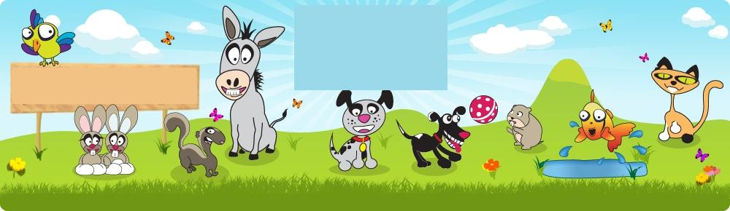

MCj04241340000[1]

What are the advantages of having a pet?

Is having a pet costly? How’s that?

j0426030

**1**

**2**

**3**

**4**

MCj04246960000[1]MCj04283450000[1]MCj04247020000[1]

What things must an owner do/provide for his/her pet?

Which would you rather have an electronic or a living pet why?

**9**

**8**

**7**

**6**

**5**

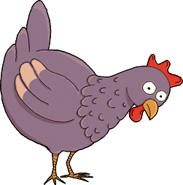

Would your parents let you have a pet?

Which pets are the easiest to take care of?

Which do you rather have to keep you company a person or a pet? Why?

MCj04300090000[1]

**10**

**11**

**12**

**13**

**14**

MCj04283610000[1]MCj04241360000[1]MCj04260320000[1]

Which pets do you think are most popular in your country? Why?

What things can a pet offer his owner?

**19**

**18**

**17**

**16**

**15**

Can pets be dangerous? How’s that?

If you had to buy a pet, which kind of pet would you choose?

Why?

What are the disadvantages of having a pet?

MCj04283470000[1]MCj04283650000[1]



**20**

**21**

**22**

**23**

**24**

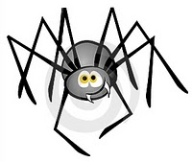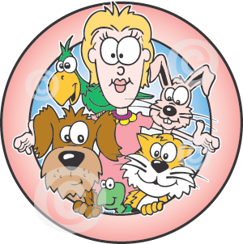j0424126

If pets would say something to people what would they say?

What do pets need most?

**25**

**26**

**27**

**28**

Instructions:

Divide your pupils into groups. Group leaders cast the dice. The group that gets the highest number on the dice starts first.

Each group casts the dice. If it lands on the picture of a pet, the group has to name it and give information about to it (what it eats/ where it lives)

If it lands on a question, the pupils have to discuss it. (give a one minute talk about it)