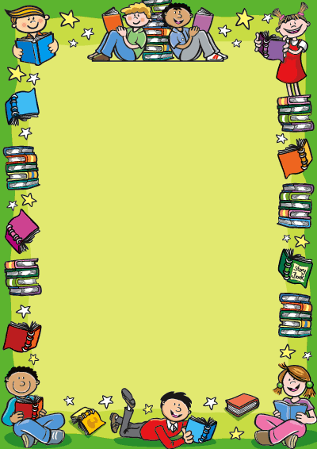

**This book « play and learn (1) » is a series of colourful board games meant to help teachers furnish the 7th GRADE pupil’s hour (3rd hour) at preparatory schools.**

**These board games cover almost all the sections of the syllabus. We hope they will help the pupils interact with each other using the language patterns acquired throughout the lessons. We hope that the idea of playing to win will weaken the students’ inhibition and give them the opportunity to practise the language in a stress-free context.**

**The authors**

**We would like to offer special thanks to MRS NAJOUA BEN ALI since she has motivated us to collaborate and she has always endorsed team work the thing that gave us the will to work on this project.**

**We would also like to thank our families for their patience and support.**

1. **TELL ME ABOUT YOUR FAMILY**
2. **WHAT ARE YOUR HOBBIES?**
3. **HOW DO YOU SPEND YOUR DAY?**
4. **WHAT’S HAPPENING?**
5. **AT THE AIRPORT**
6. **TIME FOR LUNCH**
7. **THE HOUSE**
8. **WELCOME TO THE FARM**
9. **CLOTHES BOARDGAME**
10. **HAPPY BIRTHDAY**
11. **YOU MUST BE CAREFUL**
12. **MCj04361610000[1]PARTS OF THE BODY**
13. **WHAT’S THE MATTER?**
14. **LET’S KEEP FIT**
15. **WHAT’S THE WEATHER LIKE?**
16. **AT SCHOOL**
17. **SUMMATIVE BOARDGAME**

**Instructions:**

-Divide your pupils into groups. The leaders of each group roll the numbers dice. The group that gets the highest number starts first.

-In this game pupils are supposed to introduce all the family members in the family tree with reference to “SARAH”

-Each time a different group member casts the family dice and introduces the family member it lands on, using the information in the box next to the pictures.

- If he/she makes a mistake or; if the same group lands on the same family member twice the dice moves automatically to the next group.

The winner is the group that finishes introducing all the family members correctly first.

**Suggestion for a follow-up:**

- Pupils can write a paragraph in which they will make “SARAH” introduce herself and her family.

- Sarah’s personal information are left to the pupils preferences.

***Look at the family tree and introduce Sarah’s family members:***

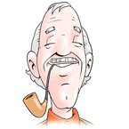 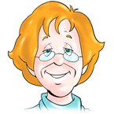

**NAME: JACK**

**AGE: 65**

**JOB: DOCTOR**

**NAME: MARY**

**AGE: 58**

**JOB: TEACHER**

**NAME: BILL**

**AGE: 45**

**JOB: JOURNALIST**

**NAME: JUDY**

**AGE: 34**

**JOB: DENTIST**



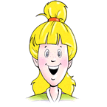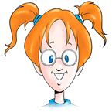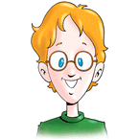

**Me : SARAH**

**NAME: SALLY**

**AGE: 12**

**JOB: PUPIL**

**NAME: SAM**

**AGE: 10**

**JOB: PUPIL**

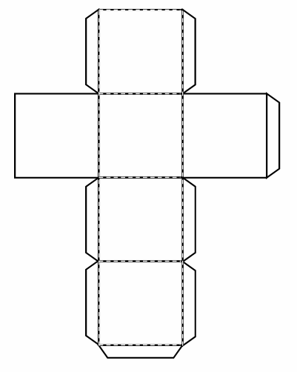









**Instructions:**

You need:

1) A numbers dice.

2) A personal pronouns dice.

3) A likes/dislikes dice.

4) Counters

Divide your pupils into groups. Group leaders cast the numbers dice. The group that gets the highest number on the dice starts first.

When it’s their turn to play, groups have to cast the numbers dice first. Each time it lands on a picture representing a hobby, the pupils have to label it then cast the two remaining dices to make a sentence with the personal pronoun and the expression of likes/dislikes the dices land on.

P.S: This game can also be an opportunity to introduce or recycle possessive adjectives

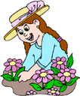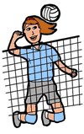**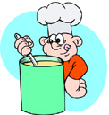**



**MCj03966820000[1]**MCj03967340000[1]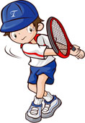

MCj03967240000[1]MCj04300730000[1]

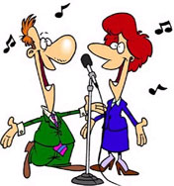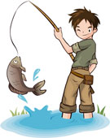

j0285698MCj04281330000[1]

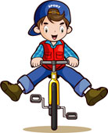

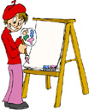

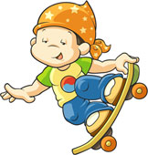**MCj03975180000[1]**MCj03974360000[1]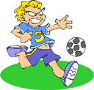

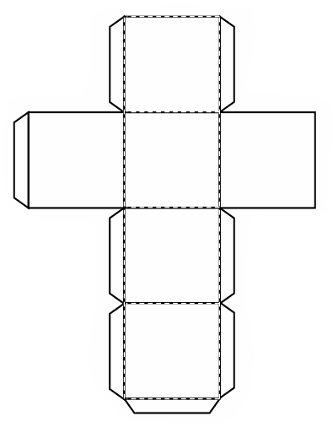







Instructions:

To play this game you need:

1) a numbers dice

2) The adverbs dice

3) Counters

Divide your pupils into groups. Group leaders cast the number dice. The group that gets the highest number on the dice starts first.

Pupils will cast the “numbers dice” and the “adverbs dice” at the same time.

1) If the numbers dice lands on a picture, pupils have to make a sentence describing it using the pronoun “HE” to talk about the boy on that picture. They will also include the adverb on the adverb dice in their sentence.

2) If it lands on an incomplete sentence, they have to finish it using the pronoun “I” and the adverb on the adverb dice as well.

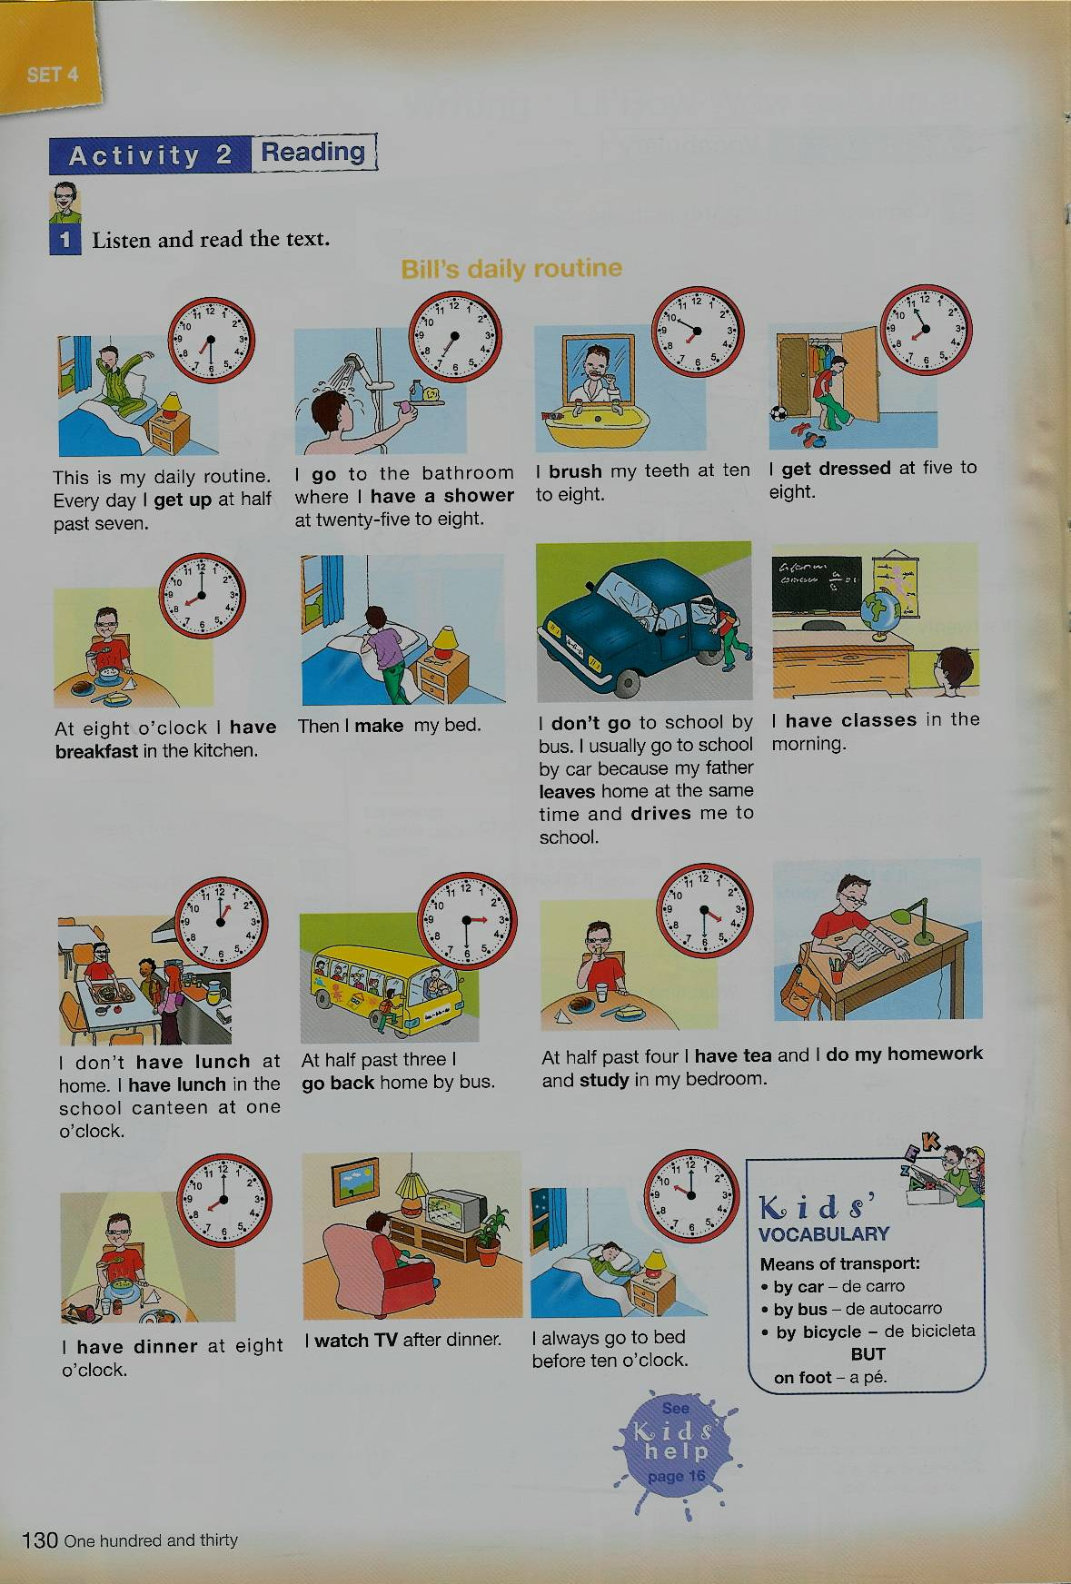

I eat/drink ...

for

breakfast

In the morning, I...

After dinner, I …

In the afternoon, I…

I have lunch at … / For lunch, I eat …

After breakfast, I ….

4

3

2

1

5

10

9

8

7

6

11

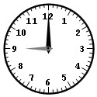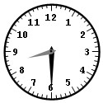

16

15

14

13

12

17



**Instructions:**

Divide your pupils into groups. Group leaders cast the dice. The group that gets the highest number on the dice starts first.

Each group casts the dice:

1) If it lands on a picture, pupils have to describe what people on the picture are doing.

2) If it lands on a caption, pupils have to cast the “personal pronoun” dice and make a sentence in the present progressive with the personal pronoun on the dice.

In both cases, pupils have to choose one of the cards below. The cards will be put face down on the teacher’s desk indicating whether the sentence should be in the interrogative/ negative/ affirmative form.

Affirmative

Negative

Interrogative



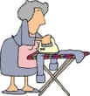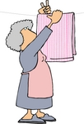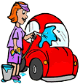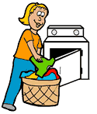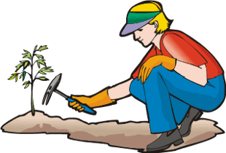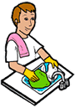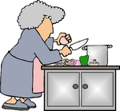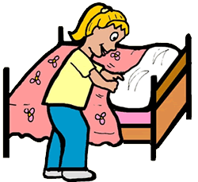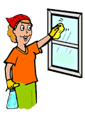

**6**

**7**

**8**

**5**

**19**

**9**

**18**

**17**

**4**

**10**

**15**

**16**

**11**

**14**

**13**

**12**

**2**

**1**

**3**

Water the plants

Set the table

Iron the clothes

Serve dinner

Hang the laundry on the clothesline

Tidy up the living room

Feed the cat

Park the cars in the garage

Make a cake

Sweep the floor

Take the children to school

Put the clothes in the wardrobe

Instructions:

Divide your pupils into groups. Group leaders cast the dice. The group that gets the highest number on the dice starts first.

Each group casts the dice. If it lands on a picture, the group has to label the picture and use it in a sentence. If it lands on a square containing a caption, the pupils have to answer back.

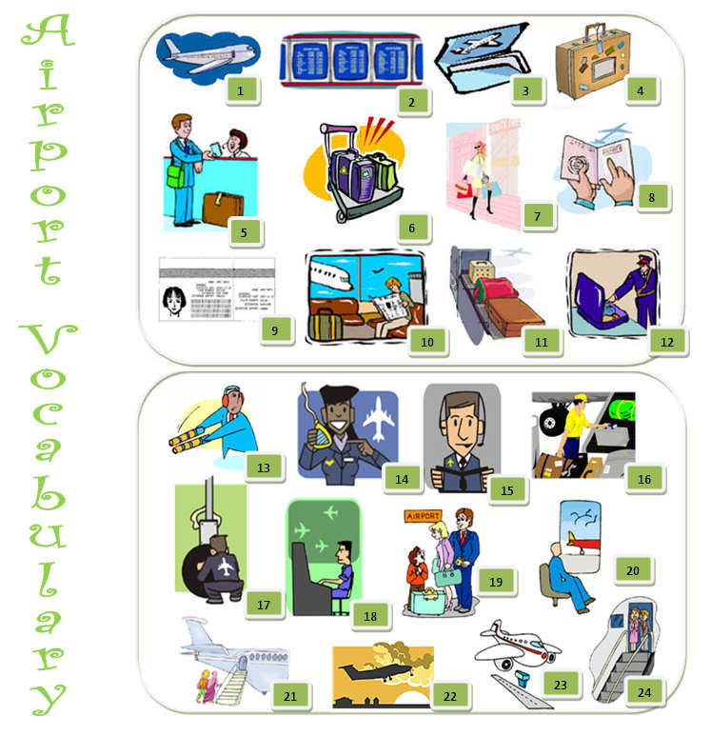[](http://www.clipart.com/en/close-up?o=3740722&memlevel=A&a=c&q=PLANE&k_mode=all&s=64&e=84&show=&c=&cid=&findincat=&g=&cc=&page=4&k_exc=&pubid=)[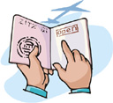](http://www.clipart.com/en/close-up?o=3835596&memlevel=A&a=a&q=PASSPORT&k_mode=all&s=1&e=21&show=&c=&cid=&findincat=&g=&cc=&page=&k_exc=&pubid=)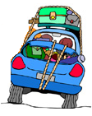[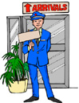](http://www.clipart.com/en/close-up?o=3941803&memlevel=A&a=c&q=AIRPORT&k_mode=all&s=1&e=21&show=&c=&cid=&findincat=&g=&cc=&page=1&k_exc=&pubid=)[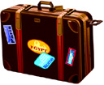](http://www.clipart.com/en/close-up?o=3928440&memlevel=A&a=c&q=SUITCASE&k_mode=all&s=1&e=21&show=&c=&cid=&findincat=&g=&cc=&page=&k_exc=&pubid=)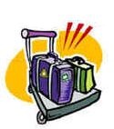

Nice to meet you

Can I see your passport?

Thank you very much.

A

I am a tourist. I am staying in London for a week.

Where are you staying in London?

Can I see your ticket, please?

Good bye.

Where do you come from?

Is there someone waiting for you in the lounge?

**Instructions:**

Divide your pupils into groups. Group leaders cast the dice. The group that gets the highest number on the dice starts first.

Each group casts the dice. If it lands on a picture, the group has to label the picture; write the word correctly on the board and try to answer the following questions:

What is it?

How does it taste/smell

Do you like it?

Is it good or bad for your health?

Is it a fruit, vegetable, drink or fast food?

If it lands on an instruction; the group has to follow it.

The first group that reaches the finish square is the winner.

**SUGGESTIONS FOR A FOLLOW-UP:**

**Role-play:**

Pupil (A) invites two friends for dinner.

Pupil (B) accepts the invitation and thanks him/her.

Pupil (C) declines the invitation, apologizes and gives a reason.

18

17

16

Your mother invites you to taste the soup. Refuse and express dislikes.



MCj04132500000[1]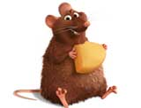

0

19

15

1

You are

eating couscous at a friend’s house. Express appreciation.

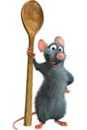

BD08049_http://dclips.fundraw.com/pngmax/bread_01.png

MCFD01017_0000[1]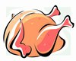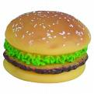BD08888_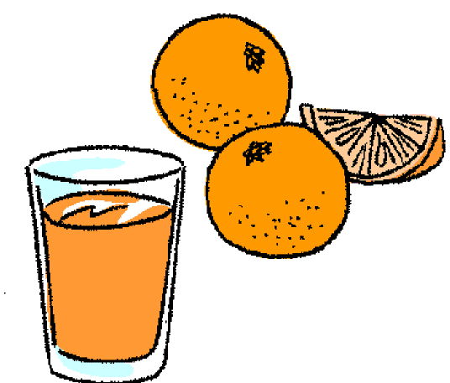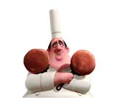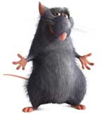FD00963_

14

13

12

11

10

9

8

7

6

5

4

2

3

Draw 3 briks in a plate.

You smell a nice flavour

of cake coming from the kitchen. Express appreciation.

Your friend invites you

to have some potato chips.

Accept and express likes.

Invite a classmate to have some pizza.

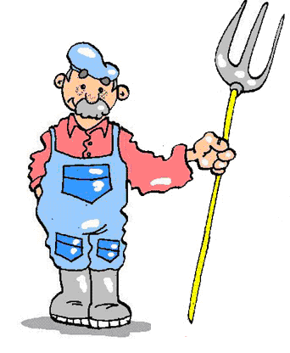

Instructions:

Divide your pupils into groups. The different groups of pupils roll the number cube. The group that gets the highest number starts first and so on. Following this order, each group throws the dice and moves the number of spaces on it.

If they land on a square containing a picture, they have to label it and write the word on the board correctly.

If pupils don’t find the word or find it and spell it wrong they don’t get a point.

Continue to play until a group reaches the finish square.

You can stop when you get a winner or continue to see who finishes 2nd and 3rd.

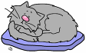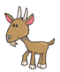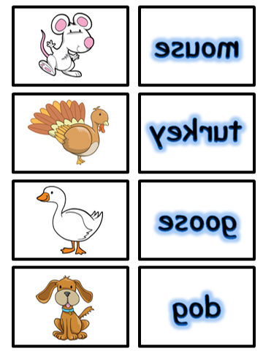j0138275[1]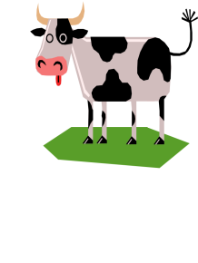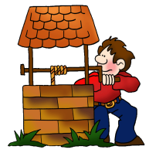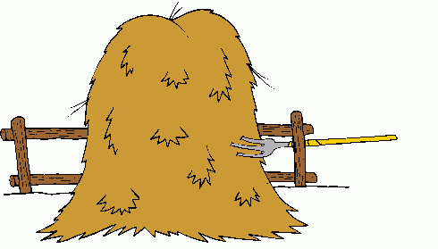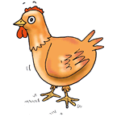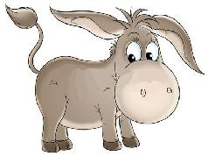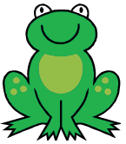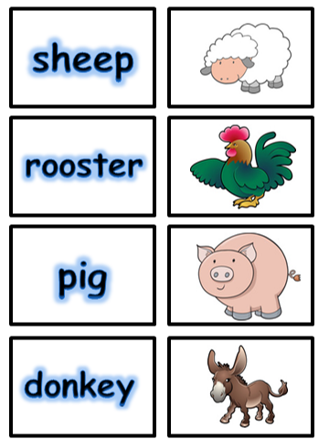j0434575[1]MCj04239900000[1]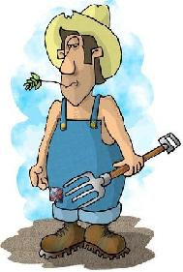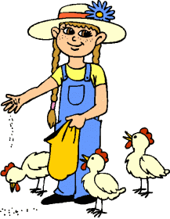MCj04241340000[1]MCj04300090000[1]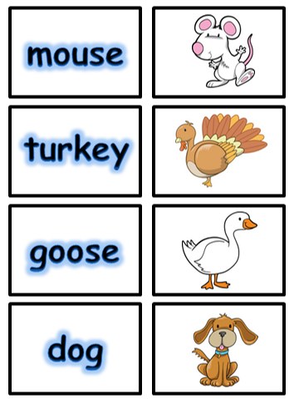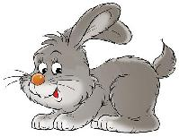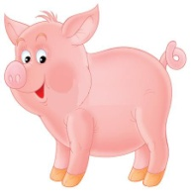MCj04283610000[1]MCj04246860000[1]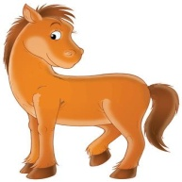

Instructions:

Divide your pupils into groups. Group leaders cast the dice. The group that gets the highest number on the dice starts first.

Each group casts the dice. If it lands on a picture, pupils have to label it and write the word on the board. If it lands on a “take a card” square, they have to pick up a card from the ones given and follow the instructions on it: (solve a riddle, describe what people are wearing…)

Cards should be put face down on the teacher’s desk as follows, for students to pick.

Cards

# 

16

15

14

**Take a card**



1

17

13



**Take a card**

18

12

**Take a card**

Take a card

2



19



11

3

HAT2

**Take a card**

SOCKSSKIRTPLT

**Take a card**

**Take a card**

**DRESS1**

20

M1787

10

4

21

9

5

**HAT**

6

7

8



MCj03970740000[1]

What’s the name of the shop that sells clothes?

Men wear me on their necks.

Describe what one of your classmates is wearing.

MCj03970740000[1]



MCj02875040000[1]you stole a sweater from a clothes shop and you got caught! Stay there until you get a “6”



[](http://images.google.com/imgres?imgurl=http://i21.piczo.com/view/4/1/b/c/0/v/b/b/g/n/0/1/img/t320373848_46041_6.gif&imgrefurl=http://web.piczo.com/zone/graphics/franzoesisch/%3Fq%3D%26p%3Dg%26o%3Dp&h=77&w=95&sz=7&hl=fr&start=6&tbnid=rbjbeb_fLeLl_M:&tbnh=65&tbnw=80&prev=/images%3Fq%3Dt%25C3%25AAte%2Bde%2Bmort%2Bclipart%26gbv%3D2%26hl%3Dfr%26sa%3DX)



What’s she wearing ?

What’s she wearing ?

What is he wearing ?



What’s he wearing ?



Reorder the letters to get the name of a clothing garment. (We wear them in our feet.)

« STOBO »

What’s he wearing ?

MCj04245740000[1]

Name three garments/ accessories you wear when it’s hot and sunny.

MCj04245740000[1]

Name three garments / accessories you wear when it’s snowing.

MCj04245700000[1]Name 1 garment we wear on our hands.

[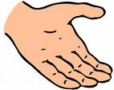](http://images.google.com/imgres?imgurl=http://www.pieravenuebaptistchurch.org.uk/Links%2520hand.gif&imgrefurl=http://www.pieravenuebaptistchurch.org.uk/Links.htm&h=607&w=767&sz=8&hl=fr&start=7&tbnid=YuoEl2q02n3XtM:&tbnh=112&tbnw=142&prev=/images%3Fq%3Dhand%2Bclipart%26gbv%3D2%26hl%3Dfr%26sa%3DX)

**Instructions:**

Divide your pupils into groups. Group leaders cast the dice. The group that gets the highest number on the dice starts first.

Each group casts the dice. The group has to make a sentence expressing obligation, prohibition or warning depending on what the instruction on the square they landed on is.

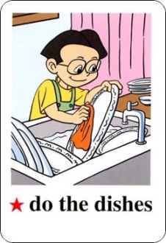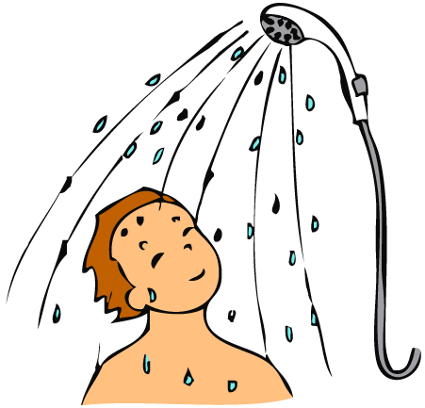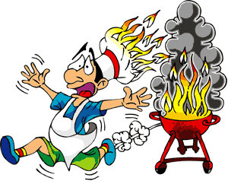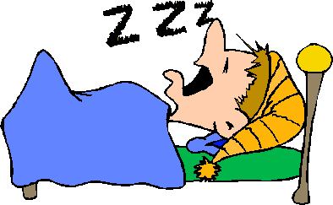j0404609j0428425[1]j0415986[1][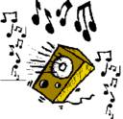](http://www.tendringdc.gov.uk/NR/rdonlyres/449DFA73-8686-4979-8596-43407076F7B6/0/Loudmusic.gif)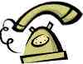hh01631_[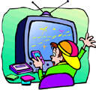](http://www.clipart.com/en/close-up?o=3813207&memlevel=A&a=a&q=hobbies&k_mode=&s=91&e=108&show=&c=&cid=&findincat=&g=&cc=&page=6&k_exc=&pubid=)CLEANING TEETH1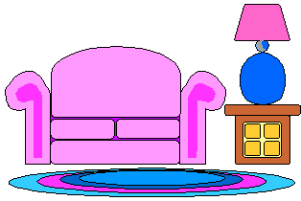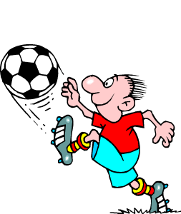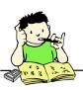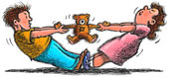MCj02321510000[1]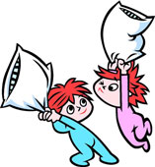

18

17

16

15

14

13

12

11

10

9

8

4

1

5

6

7

3

2

**Obligation**

Brush teeth after dinner

**Warning**

Stay late Watching TV

**Prohibition**

Pillow fight

**Prohibition**

Play loud music

**Warning**

Play with dangerous things

**Obligation**

Take a shower before going to bed

**Prohibition**

Fight over toys

**Warning**

Play with matches

**Obligation**

Do homework

**Prohibition**

Play football in the living room

**Warning**

Use the phone to call friends

**Obligation**

Sleep early

**Warning**

Invite friends

**Prohibition**

Cook anything on your own

**Obligation**

Wash your plates after dinner

**Prohibition**

Stay late playing videogames

**Warning**

Eat much sweets

**Obligation**

Call if there is a problem

INSTRUCTIONS:

Divide your pupils into groups. Group leaders cast the dice. The group that gets the highest number on the dice starts first.

Each group casts the dice. If it lands on a picture, the group has to label it and write the word on the board correctly. If they land on a square containing an instruction, they have to follow it: “Draw the part of the body” (Total Physical Response)

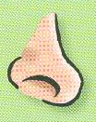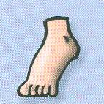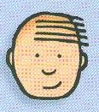

**8**

**6**

DRAW

A

KNEE

**7**

DRAW

A SHOULDER

**10**

**9**

**5**

DRAW

AN

ELBOW

**11**

**4**

DRAW

A

FINGER

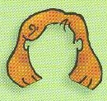

**12**

DRAW

A

NECK

**3**

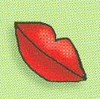

**16**

**15**

**14**

**13**

DRAW

A

FACE

DRAW

A

TOE

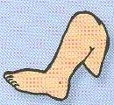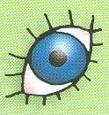

**2**

DRAW

AN

ANKLE

**17**

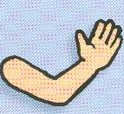

**1**

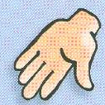

**19**

**18**

**Finish!**



DRAW

TEETH

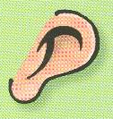

**Start**

INSTRUCTIONS:

Divide your pupils into groups. Group leaders cast the dice. The group that gets the highest number on the dice starts first.

Each group casts the dice. If it lands on a picture, the group has to label the picture and use it in a sentence expressing obligation/ prohibition or advice.

If they land on an instruction, they have to follow it.

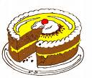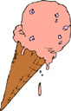

**Your fat friend is very lazy tell him what to do.**

**Your friend is fat give him/ her advice to keep fit.**

**Give 3 examples of unhealthy / junk food.**

**Your sister is very skinny. Give her advice to eat well.**

**Your friend doesn’t eat at home and s/he loves sandwiches and pizza. Give him /her advice.**

**Your father smokes many cigarettes and drinks much tea and coffee.**

**Your friend eats much bread and spaghetti. What must he do?**

**Your brother has 4 meals a day. What must he do?**

**Tell a friend about how you keep fit.**

**Tell your classmates what fruits and vegetables are good for?**

**Give 3 examples of healthy food.**

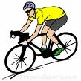

**5**

**4**

**3**

**2**

**1**

BD08049_

FD00963_

**6**



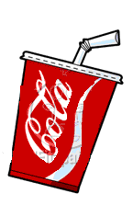

**12**

**11**

**10**

**9**

**8**

**7**

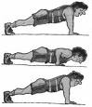

**18**

**17**

**16**

**15**

**14**

**13**

MCj03615940000[1]

MCj02871020000[1]MCj02320490000[1]

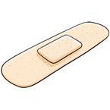

MCj04114060000[1]

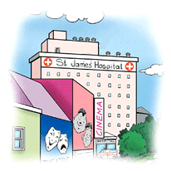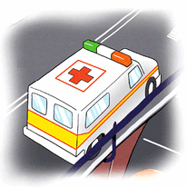

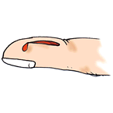MCj03317280000[1]

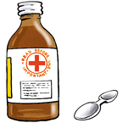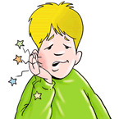

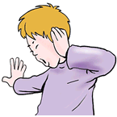

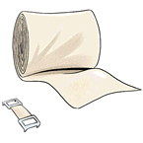

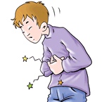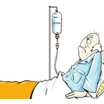



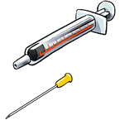

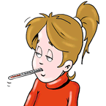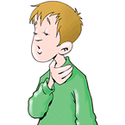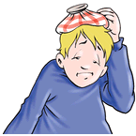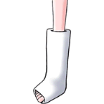MCj04301010000[1]

Instructions:

Divide your pupils into groups. Group leaders cast the dice. The group that gets the highest number on the dice starts first.

Each group casts the dice. If it lands on a picture, the group has to label the picture and write the word correctly on the board.

If it lands on a square containing a red crescent, pupils have to make a dialogue between a doctor and a patient and express advice, obligation …

MCj04301010000[1]

Example:

Patient: Good morning Doctor

Doctor: Good morning. What’s the matter?

Patient: My back hurts.

Doctor: What happened?

Patient: I fell off my bicycle…

Doctor: Let me see, this isn’t very serious. You must just stay in bed for 2 days.

[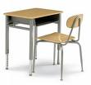](http://images.google.com/imgres?imgurl=http://www.smithsystem.com/images/products/01273-mp.jpg&imgrefurl=http://www.smithsystem.com/productCategory.asp%3FcategoryID%3D375&h=233&w=250&sz=7&hl=fr&start=5&tbnid=lZZJl9Tk8ov7bM:&tbnh=103&tbnw=111&prev=/images%3Fq%3Dstudent%2Bdesk%26gbv%3D2%26hl%3Dfr)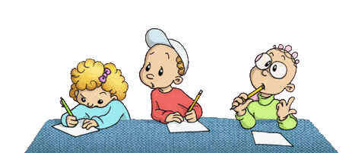[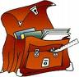](http://images.google.com/imgres?imgurl=http://www.ptitclic.net/rentree/cartable.gif&imgrefurl=http://www.ptitclic.net/sommairerentree.htm&h=150&w=153&sz=16&hl=fr&start=2&tbnid=cw1Pct9YUYezoM:&tbnh=94&tbnw=96&prev=/images%3Fq%3Dcartable%2Bclipart%26gbv%3D2%26hl%3Dfr)MCj03974640000[1]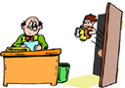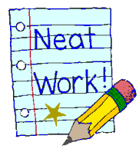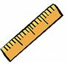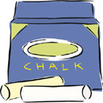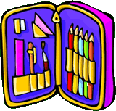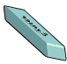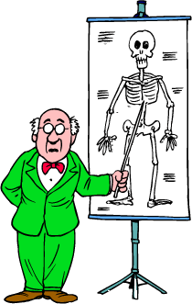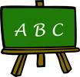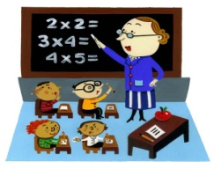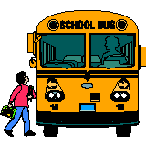

# Take the

# Shortcut

## Pass

**Take a card**

# START

**Take a card**

**Take a card**

**Take a card**

**Take a card**



**Take a card**

Take a card



**Take a card**

**FINISH**

**Take a card**

**Take a card**

**Take a card**

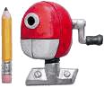

**You are the teacher’s pet. Have another turn.**

**You didn’t revise for a class test. Go back two spaces.**

**What’s there in your schoolbag?**

**What’s the name of the school’s headmaster?**

**You helped a classmate with his/her homework. Move on two spaces.**

**What was your last lesson about ?**

**Who is sitting behind you?**

**Who is sitting on your left?**

**Who is sitting on your right?**

**What’s on the teacher’s desk?**

**What’s in your pencil case?**

**Who is your favourite classmate?**

**When do you start school on Monday?**

**You haven’t written your lesson. Miss a turn.**

**Your exam results are excellent. Have another turn**

**What’s your favourite school subject?**

**You left your school bag in the bus go back two spaces.**

**Name one of the class rules**

Who is your favourite teacher?

**You lost your pencil go back two spaces**

**Your teacher caught you passing a note! Go back three spaces.**

INSTRUCTIONS:

Divide your pupils into groups. Group leaders cast the dice. The group that gets the highest number on the dice starts first.

Each group casts the dice. If it lands on a picture, the group has to label the picture and write the word correctly on the board.

If they land on a “take a card” square, pupils have to take a card, read the instruction and follow it.

**Instructions:**

This game is intended to be done at the end of the school year to sum up and review everything that has been covered throughout all the lessons.

Prepare a dice. Divide your pupils into groups. Groups will move from one square to another following the instructions in each square until they reach (THE END).

Each time group leaders will cast the dice to find out which group will play (That’s to say the group that gets the highest number).

If a group fails to answer or gives an incomplete answer, then the group with the nearest number will take on.



**START**

**Name 3 things you can find at the airport**

**Tell me 3 places at school**

**Name**

**4 pieces of furniture**

**Name 3 birthday presents**

**Name 6 things in the classroom**



**Name 3 cold drinks**

**Name 4 farm animals.**

**Tell the date**

**Name 5 things in your schoolbag.**

**Name 2 things to do to keep school clean**

**FINISH**

**Give 2 class rules**

**Name 5 parts of the face.**

**Name 5 family members.**

**Name 7 parts of the body.**

**Name 5 things in your pencil case.**

**Name 3 things you do before going to bed.**

**Name 3 hot drinks.**

**Name 3 things you do in the morning.**

**Name 6 things you can eat for breakfast.**

**Name 3 school subjects**

**Name 3 things you can wear in summer**

**Name 5 parts of the house**

**Give 3 adjectives to describe your ideal teacher**

**Name 3 things you must do to keep fit**

**Name 4 vegetables**

**Name 5 fruits**

**Give adjectives describing the weather (5)**

**Name 3 things in the kitchen**

**Tell me**

**4 shops**

**Tell the time**

**Name 5 things to wear in winter**

**Name**

**The 4 seasons**

**Tell me 5 things in your bedroom**

**26**

**18**

**12**

**6**

**7**

**8**

**9**

**10**

**11**

**13**

**14**

**15**

**5**

**32**

**31**

**30**

**16**

**27**

**4**

**3**

**34**

**29**

**35**

**17**

**19**

**2**

**21**

**20**

**25**

**22**

**23**

**24**

**1**